30. JUNIT TESTING TO CHECK WHETHER THE GIVEN NUMBER IS PALINDROME OR NOT

M.Anusha

192124420

AIM :

To Perform junit Testing to Check Whether the given number is palindrome or not.

PROGRAM:

Package sse;

Import java.util.scanner;

import static org.junit.Assert.assertTrue;

public class palindrome

{

public static void main(String args[])

{ Scanner in = new Scanner(System.in);

int r, sum = 0, temp; int n = in.nextInt();

temp = n;

while (n > 0)

{ r = n % 10; n = n / 10;

sum = (sum \* 10)+r; }

System.out.println(sum);

assertTrue(787==sum);

if(temp==sum)

System.out.println(sum+" is palindrome number");

Else

System.out.println(sum+”is not palindrome number”);

}

}

OUTPUT:

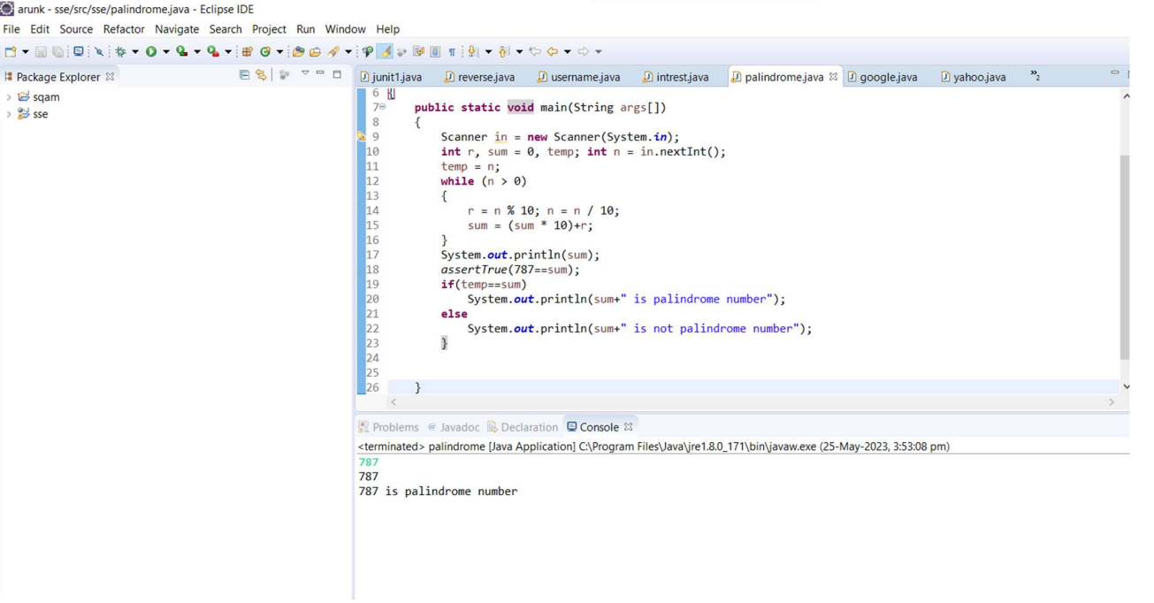

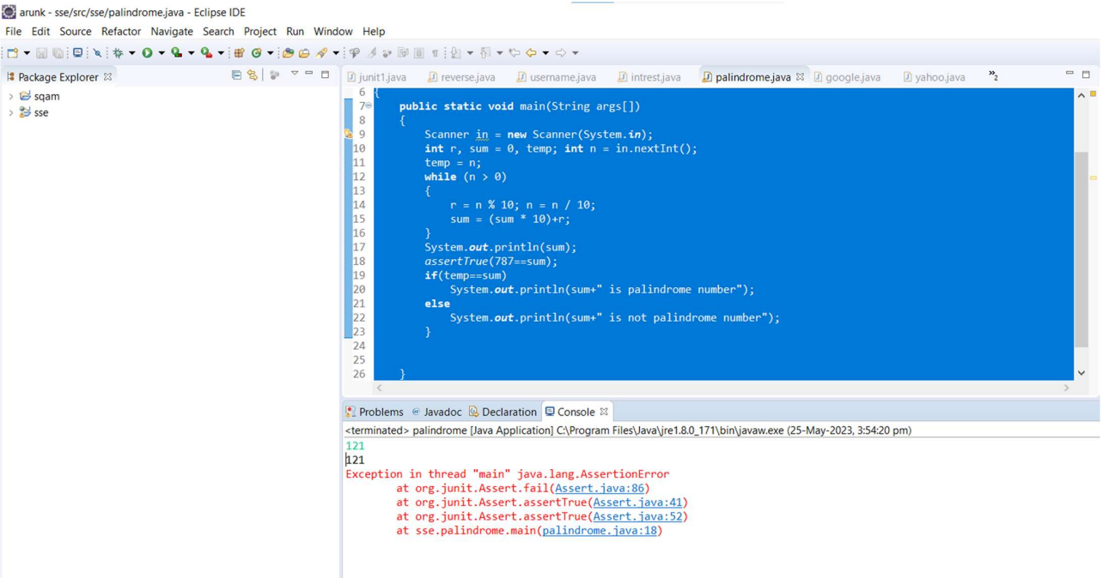

RESULT:

Hence the junit Testing Check Whether the given number is palindrome or not performed successfully.